README FILE ABOUT THE DOCTORAL DISSERTATION TEMPLATE

This template may be used during the writing of your doctoral dissertation or may be used once you have completed your work and need to transfer your work into a file that may be used by the Graduate School, K-REx (K-State Research Exchange), and ProQuest. (ProQuest is for doctoral students.) Please review the README, so that you are optimally positioned to present your research work.

Most up-to-date version of MS Word installed. Please make sure that you have the most up-to-date version of Microsoft Word from the Microsoft Office Suite (Office 365), so that your settings for High Fidelity image resolution is enabled.

Why a doctoral dissertation template? This template ensures proper formatting of the contents of a doctoral dissertation, so all the required information is present and in the proper format and order. This template also ensures easy navigation through the electronic file, when clicking on items in the Table of Contents or List of Figures or List of Tables will jump a reader directly to the proper location in the file. The contents of this template also show an informational hierarchy based on the text styles and order. As such, the contents are both human- and machine-readable. Some dissertations are comprised of a series of articles, instead of chapters, and this template can be adapted to that usage, with unique source citations and source citation methods per article.

Live Web links. Another way to ensure proper navigation is to make sure that your http links are activated. Highlight the link and apply the live linking to the text, or just click one space after the URL, and MS Word will handle the link for you.

Font type changes. In general, please use the given font in the template. However, if you are determined to change the font, change it in one location, in the area of text styles. Do not highlight text manually and change the font. (This is because of a peculiarity and efficiency of the template.)

Handling digital images. This file was set up so that all input images are not compressed inside Word (so they retain high resolution quality). The setting for all images is High Fidelity (over 300 ppi). To ingest images, please use .jpg (if image size is an issue).
If image resolution is of particular importance, go with less lossy digital image formats like .png or .tif. Ensure that the image is as high resolution as possible. Typical image standards for publication are 350 dpi at minimum. Color for print is CMYK format (vs. RGB for web). [CMYK represents “cyan, magenta, yellow, black,” and “RGB” represents “red, green, blue.”]
While your template initially begins as a Word file, it will ultimately be transcoded into a navigable .pdf file for digital archival and distribution. The various features of the original Word template should transfer completely into the .pdf format.

List of Abbreviations / List of Terms / List of Equations? Some works contain a list of abbreviations. Where these are placed and how they are formatted depend on the discipline. For some disciplines, the List of Abbreviations follows the List of Tables. For others, this list may appear elsewhere in the formal thesis. The formal sequence to place anchors for the respective elements would be the same sequence: References tab -> Captions -> (Object).

Placing figures and tables. Please review your research source citation method (bibliography format) to understand the standards for figure captioning and table captioning. Should the titles be in title case? Sentence case? Where do notes go? Should the table have vertical lines? Horizontal ones? What should the font size be for the table data? The bibliography method usually defines these and other standards.
When placing figures and tables (and their related captions), make sure that you have a blank line between the caption and the body or normal text. (Use only one or the other throughout.) Having a blank line ensures that the template does not read the body or normal text as if it were part of the caption and pulling that content then into the List of Figures or List of Tables. [If you see a figure or table in the Table of Contents, the List of Figures, or the List of Tables, go to the figure or table. Highlight the figure or table, and make sure that the figure or table is “body text” style, not “caption” style.]

Bibliographic citations. Different disciplines have different standards for citing sources both in-text and in the bibliographic listing at the end. These standards also determine labeling for figures and tables. It is important to be correct and consistent in the citations.
If you are using a third-party reference management software or cloud service, make sure to keep your online libraries synchronized and your files as clean as possible. Otherwise, these may result in challenges to your thesis / dissertation.

The show/hide ¶ (paragraph) mark: At the middle of the Home tab ribbon is the “¶” (show/hide paragraph) icon. You can use this as a toggle to turn off the paragraph coding to see where section breaks and other coding exist. Use this so that you do not accidentally delete section breaks (and cause problems for pagination of sections). However, when you are ready to output the .pdf, toggle this back off so that these symbols do not ruin your pagination spacing. These add space even if the .pdf does not show the ¶ formatting.

Proper name of student, proper file name format. The format for your filename is FirstnameLastnameYYYY.pdf. Note the capitalization of the first and last name and the lack of any blank spaces in the name. The year is represented with four numbers. An example would be WillieWildcat2024.pdf. In some cases, various middle names or middle initials may be included. The important thing is to ensure that K-State has the correct name on record (Log into KSIS. Go to the Profile file. Check the top “Primary” name, and ensure that that is what is reflected in the ETDR for its file name, and various other locations. Names should be labeled consistently. Name misrepresentation is a common error. If the Registrar’s Office has an incorrect name, please contact the officials there with the correct documents to ensure that corrections are made.)

Supplementary files. Sometimes, students want to include related PowerPoint slideshows, articles, datasets, image sets, and other related contents. In most cases, you will be able to create supplementary files to complement your thesis. These may be included with your submission of your thesis into K-REx and ProQuest. Sometimes, students want to embed data tables and datasets in Word. These do not carry over into the .pdf file and have to be re-inserted from the Portable Document File format. In many cases, these .pdf files with embedded datasets may not retain the datasets when uploaded into a repository for digital storage. Please test thoroughly if you are including attached / embedded data files.

Ensuring proper pagination with accurate spacing. In the ribbon, in the Home tab, the Paragraph area, at the top right, there is a backwards ¶, which enables the viewing of formatting marks. While this feature is helpful during the formatting of the thesis / dissertation, make sure to turn these off before updating all the Table of Contents, List of Figures, List of Tables, and List of Abbreviations, so that the pagination is correct. Otherwise, the added formatting marks will lengthen the dissertation and cause inaccuracies in the pagination.

Omitting blank pages. Please review your manuscript closely, and omit any blank pages. Make sure that the new pagination is correct.

Field shading. The grayed parts of the template highlight field shading for autocoded parts of your template. Do not type directly into these fields. These fields are autopopulated.

A reference copy of the thesis / dissertation template. If you forget what the required formatting is, download a reference copy of the thesis / dissertation, and use it as reference. You can copy and save this front piece for later reference or leave this README in place until your file is ready to finalize and process into a .pdf file.
When you remove the README, and you update the Table of Contents, the List of Figures, and the List of Tables, the pagination in your dissertation will auto-update. Please check to make sure that the pagination is correct, though.

Highlighted notes. In this template, there are some highlighted parts (in yellow) to further explain how the template works. Those should be deleted before you finalize your file.

Maximum .pdf size. There is a 10 GB size limit for ETDRs on K-REx and ProQuest. Note that this is the size of a compressed .pdf, which is often a lot smaller than the Word file.

A bound print copy of your work. To obtain a personal bound copy of your manuscript, see the option at https://www.k-state.edu/grad/etdr/template/.

What breaks an MS Word template? A template is broken irretrievably based on several issues.

To know how not to break a Word template, go to File tab -> Options (bottom of left menu) -> Advanced and go down to Field shading and select “Always”.

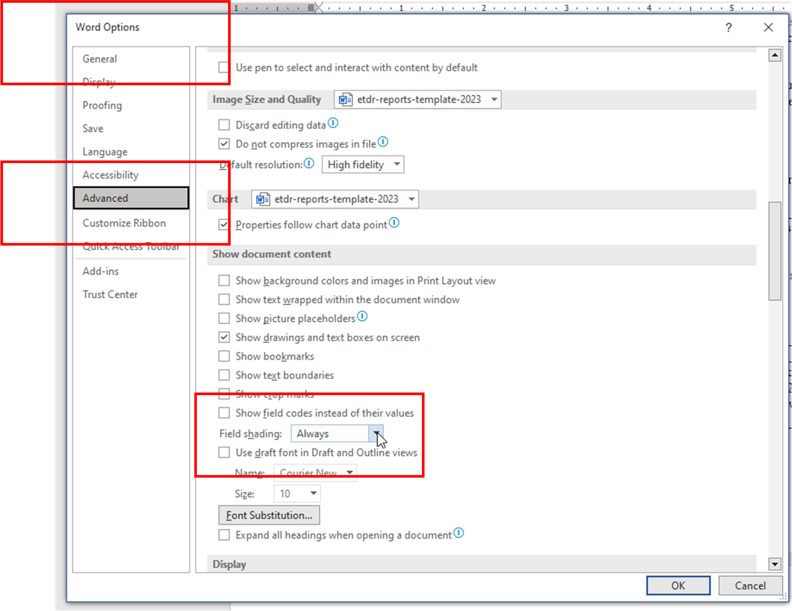

This will turn all field coding in gray text.

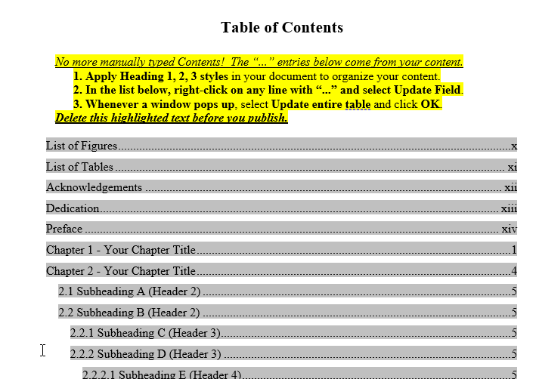

Here are the rules to follow.

- Never directly try to edit the gray text (which indicates code). Do not, for example, go to the Table of Contents and try to edit the text directly. Rather, hold down CTRL + click and jump to the source of the TOC information…and update the text in the proper style format. Return to the TOC and right-click the gray text and update the entire table in the dropdown menu. [The pagination is also in gray text, so do not edit those directly either. Use commands in Word to change the pagination.]
- Never highlight body text in the ETDR and go to the ribbon and change the font type or size. All the styles of text—Header 1, Header 2, body text, block text, and others, are controlled by code. If you want to change the text appearances across the board for that type of text, go to the Styles pane and use the dropdown to the right of the style and “Modify.” Do not have styles that have addendums like “body text + boldface + …” The plusses should not be used because that leads to inconsistencies in your document.
- Never edit the References tab for tables. The TOC, the List of Figures, the List of Tables, and so on, are tables. The table style (and navigation) is built into the template. Customizing the table style has often led to a broken template.

Oops!

Now, if you’ve broken a template irretrievably, take a deep breath. You do not have to worry. All you need to do is download an updated template from the K-State Graduate School website, and move your contents over to the new template.

Paste text in by the type of text it is.

Insert images (do not copy and paste). Make sure that the images are at sufficient resolution 350 dpi / ppi…and higher… .png and .tif are preferred formats, as .jpgs are lightweight, lossy, and prone to artifacts.

If you have tables, use Excel to scrub out the unnecessary formatting. Use Excel to control for table width if the table width is wide (9” or so). Place the table in a landscape format if needed.

Then follow the directions to process your ETDR to final format. It usually only takes an hour to complete an ETDR in a working template.

Help support. Some common challenges with Word files may be reviewed in the linked article. If you need any help, please contact the IT Help Desk at helpdesk@ksu.edu or 785-532-7722. Or you may open a service ticket via servicenow.ksu.edu. Please reach out early to have questions addressed, so that you are not rushed to finalize your work.

(2023)

Your title here in sentence case (descending case)

by

Your Official Name (as KSIS record appears)

(previous degrees with format, punctuation, and date order, as shown in examples below)
B.S., Kansas State University, 2010
M.S., University of Kansas, 2012

AN ABSTRACT OF A DISSERTATION

submitted in partial fulfillment of the requirements for the degree

(degree being earned in all capital letters, or BLOCK CAPS, as shown in examples below)
DOCTOR OF PHILOSOPHY
DOCTOR OF EDUCATION

Name of your department (example: Department of Chemistry)
Name of your college (example: College of Arts and Sciences)

KANSAS STATE UNIVERSITY
Manhattan, Kansas

Graduation Year

Abstract
Type your abstract here. There is no upper word count limit as of 2017. (In MS Word, just highlight your abstract, and a count will be available at the bottom left of your workspace.)

Your title here in sentence case (descending case)

by

Your Official Name (as KSIS record appears)

(previous degrees with punctuation, format, and date order, as shown in examples below)
B.S., Kansas State University, 2010
M.S., University of Kansas, 2012

A DISSERTATION

submitted in partial fulfillment of the requirements for the degree

(degree being earned in all capital letters, or BLOCK CAPS, as shown in examples below)
DOCTOR OF PHILOSOPHY
DOCTOR OF EDUCATION

Name of your department (example: Department of Chemistry)
Name of your college (example: College of Arts and Sciences)

KANSAS STATE UNIVERSITY
Manhattan, Kansas

Graduation Year

Approved by:  Co-Major Professor (if needed)  Name of your major professor | Approved by:  Co-Major Professor (primary)  Name of your major professor

Copyright
© Firstname Lastname YYYY.

Abstract
Dissertations require this second abstract (and the second title page, too). Copy the first abstract and paste it here (with destination formatting).
If you delete any lines on this page, KEEP the hidden Section Break below that controls page numbering. How to see it: Home tab > Paragraph section > click theicon. (On a Mac, the icon may be above the ribbon.)

Table of Contents
No more manually typed Contents! The “...” entries below come from your content.
1. Apply Heading 1, 2, 3 styles in your document to organize your content.
2. In the list below, right-click on any line with “...” and select Update Field.
3. Whenever a window pops up, select Update entire table and click OK.
Delete this highlighted text before you publish.

List of Figures xii
List of Tables xiii
Acknowledgements xiv
Dedication xv
Preface xvi
Chapter 1 - Your Chapter Title 1
Chapter 2 - Your Chapter Title 4
2.1 Subheading A (Header 2) 5
2.2 Subheading B (Header 2) 5
2.2.1 Subheading C (Header 3) 5
2.2.2 Subheading D (Header 3) 5
2.2.2.1 Subheading E (Header 4) 5
2.2.2.2 Subheading F (Header 4) 5
Chapter 3 - Your Chapter Title 6
Chapter 4 - Your Chapter Title 7
Chapter 5 - Your Chapter Title 8
References or Bibliography (choose one) 9
Appendix A Your Appendix Title 11
6.1 Subheading A (Header 2) 12
6.2 Subheading B (Header 2) 12
6.2.3 Subheading C (Header 3) 12
6.2.4 Subheading D (Header 3) 12
6.2.4.1 Subheading E (Header 4) 12
6.2.4.1.1 Subheading F (Header 5) 12

List of Figures
The List of Figures is created from figure captions in this document.
1. In your chapters, insert figure captions. You must train them (1, 2, 3, or 1.1, 1.2, 1.3, etc.).
2. Update the list below. Right-click anywhere in the list and select Update Field.
3. If a window pops up, select Update entire table and click OK.
Figure 1.1. Global Prevalence of SARS-CoV-2 mid-June 2020 (from WHO) 1
Figure 2.1. A Flowchart of Processing a Thesis, Dissertation, or Report from Word to PDF 4
Figure B.1. EXAMPLE of caption in Appendix B, with appendix identifier and number. 13

Appendix A Figure A.1 11

List of Tables
The List of Tables is created from table captions in this document.
1. In your chapters, insert table captions. You must train them (1, 2, 3, or 1.1, 1.2, 1.3, etc.).
2. Update the list below. Right-click anywhere in the list and select Update Field.
3. If a window pops up, select Update entire table and click OK.
Table 1.1. COVID-19 Cases by Race / Ethnicity (CDC, June 16, 2020) 2
Table 1.2. Median Household Income in State of Oklahoma from 2009 - 2013 (from data.gov) 2

Appendix A Table A.1 11

Acknowledgements
The Acknowledgements page is optional. If you include it, retain the Acknowledgements heading and enter your text here.

Dedication
The Dedication page is optional. If you include it, retain the Dedication heading and enter your text here.

Preface
The Preface page is optional. If you include it, retain the Preface heading and enter your text here.
If you delete this page or any lines on it, KEEP the hidden Section Break below that controls page numbering. How to see it: Home tab > Paragraph section > click theicon. (On a Mac, the icon may be above the ribbon.)

- Your Chapter Title
Add your content here. If you are pasting contents in, be sure to use destination source formatting. Do not copy and paste images and tables in along with the text. Images should be inserted with high resolution. Tables should be input with proper table formatting.

Figure 1.1. Global Prevalence of SARS-CoV-2 mid-June 2020 (from WHO)

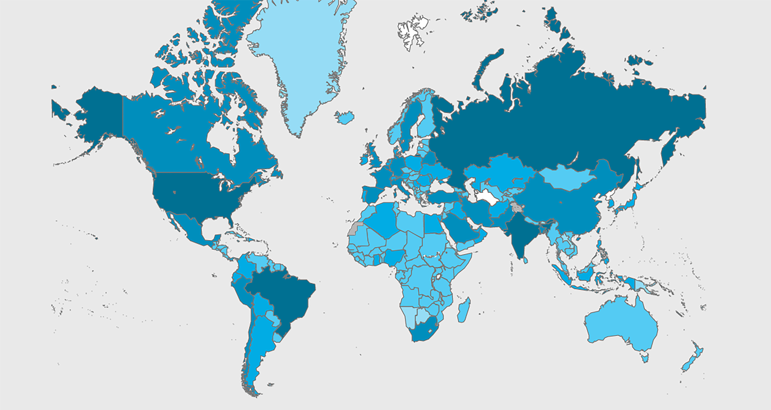

Digital images should be rendered at 350 dots per inch (dpi) or pixels per inch (ppi) for sufficient resolution and even higher depending on the focal points of the image. Also, they should be in .jpg format for size. If image resolution is of particular importance, go with less lossy digital image formats like .png or .tif, and you can use a much higher resolution (some have 1200 dpi/ppi in some images. The aspect ratios of the figures should not be distorted or stretched. Images should not be pasted in from the clipboard but inserted from the Insert tab in MS Word.
The template “anchors” are linked to the captions for the Figures and Tables. When a person navigates to a figure or table (from the List of Figures or the List of Tables), their page will show the respective target object. Notice that the figures and tables begin with the respective chapter based on auto-numbering (References tab -> Captions area).

Table 1.1. COVID-19 Cases by Race / Ethnicity (CDC, June 16, 2020)
Cases by Race/Ethnicity
Date generated: Tue Jun 16 2020 11:45:37 GMT-0500 (Central Daylight Time)
Race/Ethnicity | Percentage | Count
Hispanic/Latino | 16.1 | 292206
American Indian / Alaska Native Non-Hispanic | 0.6 | 11181
Asian Non-Hispanic | 1.9 | 33889
Black Non-Hispanic | 10.4 | 189964
Native Hawaiian / Other Pacific Islander Non-Hispanic | 0.1 | 2637
White Non-Hispanic | 16.8 | 304817
Multiple/Other Non-Hispanic | 2.1 | 37765
Unknown | 52 | 946298

Table 1.2. Median Household Income in State of Oklahoma from 2009 - 2013 (from data.gov)
Years | Historical Data | Target
2009 | $41,664.00
2010 | $42,072.00
2011 | $43,225.00
2012 | $44,312.00
2013 | $45,690.00
2014
2015
2016
2017 |  | $51,424.00

- Your Chapter Title
Add content here.
Figure 2.1. A Flowchart of Processing a Thesis, Dissertation, or Report from Word to PDF

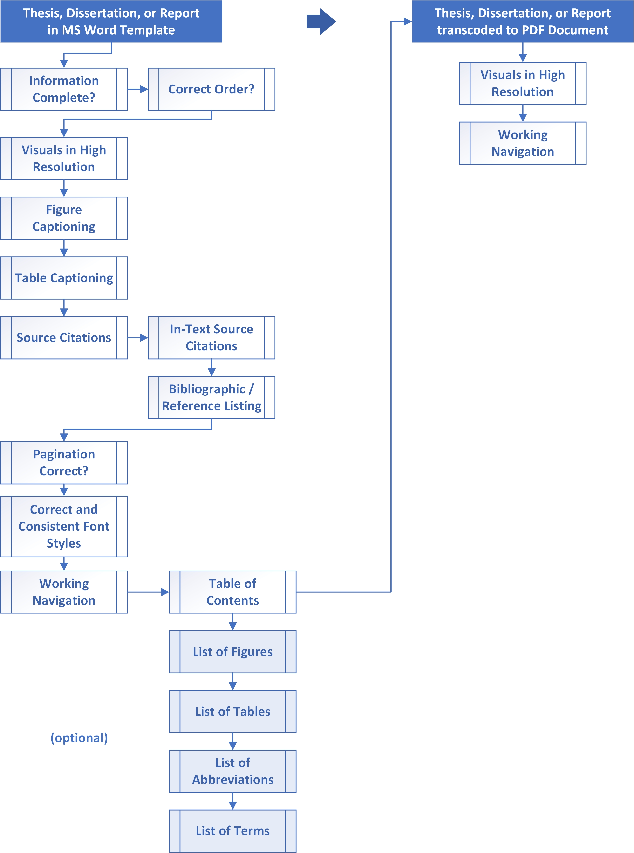

Subheading A (Header 2)

Subheading B (Header 2)

Subheading C (Header 3)

Subheading D (Header 3)

Subheading E (Header 4)

Subheading F (Header 4)

- Your Chapter Title
Add content here.

- Your Chapter Title
Add content here.

- Your Chapter Title
If you need more chapters, follow these steps:
1. Insert a Page Break (Insert > Page Break), because chapters start on a new page.
2. Type the name of the chapter and apply a Heading 1 style (Home > Heading 1).

Placeholder

References or Bibliography (choose one)
Include a separate chapter for your references or bibliography. Citations can be single- or double-spaced (but consistent). They must be followed by a blank line. The rest of the format is entirely up to you and your adviser.
The Bibliography style does not format your citations into a specific style such as American Psychological Association (APA), Modern Language Association (MLA), Chicago Style, or others. You must enter your citations in the style used by your department, or use bibliographic software such as RefWorks, EndNote, or Mendeley.
If using a cloud-based bibliographic software, be sure to update all of your sources. Ensure that these are accurate. Make sure to update the versions of your work in all installed versions on different machines. In MS Word, bring in your sources. Reconcile any broken links (or failed intake of particular sources). Then, highlight the entire list, and apply the Bibliography style. This style means that all sources are single spaced, and there is a blank line between each entry. If there are broken lines, backspace from the front of the dangling lines so that the entries show correctly in the Bibliography.
For assistance with citations, contact K-State Libraries (at www.lib.k-state.edu) and see its Citations and Bibliographies information at guides.lib.k-state.edu/citations.
Below are examples of a Bibliography style in this template (single spacing, hanging indent, a blank line afterward, and a rough right edge). It meets the needs of many students. You can modify it as needed to meet departmental requirements.

Devine, P. G., & Sherman, S. J. (1992). Intuitive versus rational judgment and the role of stereotyping in the human condition: Kirk or Spock? Psychological Inquiry, 3(2), 153-159.
Hodges, F. M. (2003). The promised planet: Alliances and struggles of the gerontocracy in American television science fiction of the 1960s. The Aging Male, 6(3), 175-182.
James, N. E. (1988). Two sides of paradise: The Eden myth according to Kirk and Spock. In D. Palumbo (Ed.), Spectrum of the fantastic (pp. 219-223). Westport, CT: Greenwood.

Your Appendix Title

Difference between chapters and appendices:
- Chapters contain essential information, including tables and figures. Appendices are for supplemental data. There’s no limit on the number of chapters or appendices.
- From Chapter 1 on, the content and format of your research is up to you, your adviser(s), and your graduate committee. You have many choices on fonts, headings, paragraph style, tables, captions, etc. Consistency is essential.
- For details, see the Graduate School Requirements and Guidelines for Electronic Theses, Dissertations, and Reports at k-state.edu/grad/etdr/create/guidelines.html.

Appendix A Figure A.1

Appendix A Table A.1

To get this to work, you may have to highlight the numbering of the sections in the Appendix…Set Numbering Value as follows, and ensure that the first of the sequence is correct, whether the value is 6 or 7 or 8 or whatever (based on the number of chapters you have prior with the Heading 1 label).

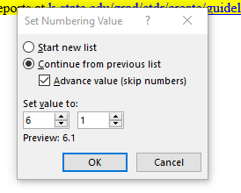

Subheading A (Header 2)

Subheading B (Header 2)

Subheading C (Header 3)

Subheading D (Header 3)

Subheading E (Header 4)

Subheading F (Header 5)

Using appendices, adding more, adding captions

What kinds of supplemental data?
- Anything you and your adviser deem relevant
- Copyright permissions
- Fair use evaluations
- Computer code and data sets
- IRB forms and letters (usually in PDF format)
- Surveys and other forms

- Appendices are optional. There is no limit on the number of appendices.
Appendix headings must be labeled Appendix guidelines
- A, B, C, etc. (tip: Use Heading 6).
- Appendix subheadings can be organized by using Headings 7, 8, and 9 in the text styles.
- Captions for figures/ tables in appendices are not required to be in the List of Figures or List of Tables, but can be included at your option.

Adding more appendices
1. Insert a Page Break (Insert > Page Break), so the next appendix starts on a new page.
2. Type the name of the appendix and apply a Heading 6 style (Home > Heading 6).
3. Word provides the “Appendix” label and correct alphabetical sequence.
Adding appendix captions
If captions in your chapters are numbered 1, 2, 3, etc., that numbering format should continue through your appendix captions. If captions in chapters are numbered 1.1, 1.2, 1.3, etc., your appendix captions must match that format by using A.1, A.2, A.3, etc.
Figure B.1. EXAMPLE of caption in Appendix B, with appendix identifier and number.


A common problem with appendix captions is that Word will label them as though they’re in a chapter (“Figure B.1” above was originally “Figure 6.1”).
One solution: Use this process only after ALL Word-automated captions have been inserted into your document. Otherwise, Word may change all the caption numbering again if you insert a new caption.
- Starting in Appendix A, carefully delete only the chapter number in each appendix caption and type in the desired appendix identifier (A, B, C, etc.).
- Be careful not to delete the Word-automated number in each caption.
- If the auto-numbering does not start at “1” (for example, it is B.6), contact the IT Help Desk and ask for an ETDR consultant to help make the fix.

